- Loading Data from SSIS to SQL Server.

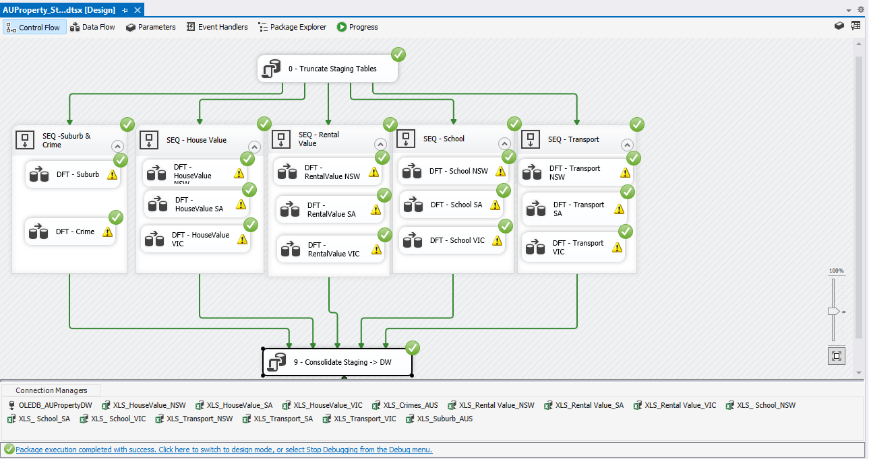

- Checking the results in SQL Server.
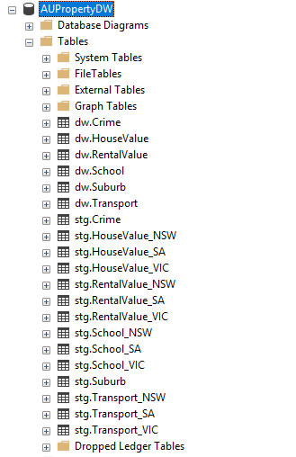

Compares each staging table's row count against the known source file row count

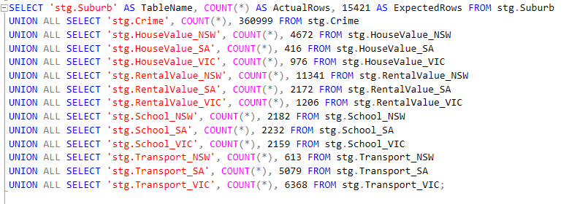
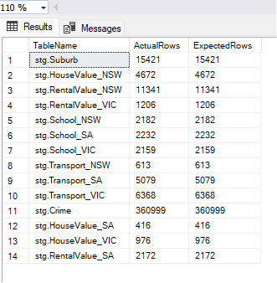

CONSOLIDATED DW LAYER COUNTS

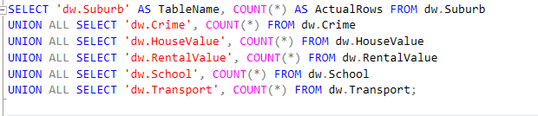
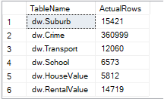

Row-count reconciliation (staging vs. consolidated)

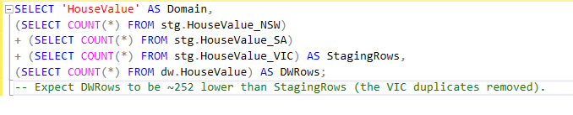
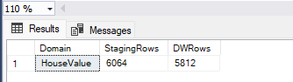

Null / blank key checks

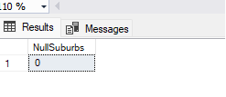
Orphan suburb check (values that don't exist in the master suburb list)

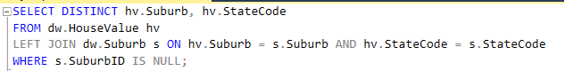

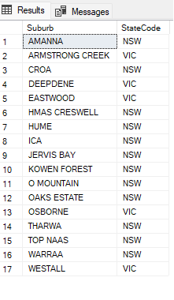
NULL / BLANK KEY CHECKS ACROSS ALL DW TABLES
